CAR SELLING PRICE PREDICTION USING MACHINE LEARNING
CH.Kalpana
241FA18305
kalpanachityala276@gmail.com

Abstract
This research paper presents an end-to-end machine learning approach for predicting the selling price of used cars using the assigned car dataset. The project is based on the actual work performed in the provided Jupyter Notebook. The dataset initially contains 20 records and 9 attributes; one duplicate record is removed, leaving 19 records. Data preprocessing includes duplicate checking, numerical and categorical feature handling, and the creation of a new Car_Age feature from the manufacturing year. Four regression models—Linear Regression, Decision Tree Regressor, Random Forest Regressor, and Gradient Boosting Regressor—are trained and evaluated using an 80:20 train-test split. Performance is measured using Mean Absolute Error (MAE), Root Mean Squared Error (RMSE), and R² Score. Linear Regression achieved the best performance with MAE 0.7799, RMSE 1.0123, and R² Score 0.7936. Random Forest hyperparameter tuning using GridSearchCV was also performed. A sample unseen car prediction produced an estimated selling price of ₹362,325.
Key Words—Machine Learning, Used Car Price Prediction, Regression, Linear Regression, Decision Tree, Random Forest, Gradient Boosting, GridSearchCV, R² Score, Data Preprocessing.
INTRODUCTION
Predicting the selling price of a used car is a regression problem in which historical vehicle information is used to estimate a continuous target value. Machine learning can identify relationships between vehicle characteristics such as present price, kilometers driven, fuel type, seller type, transmission, ownership, and vehicle age. This project develops and compares multiple regression models using the assigned car dataset.
PROBLEM STATEMENT
The problem is to develop a machine learning regression system capable of predicting the Selling_Price of a car from available vehicle characteristics. The objective is to build, evaluate, compare, and select a model based on the actual dataset and experimental results.
RESEARCH OBJECTIVES
The main objective of this research is to develop and evaluate a machine learning-based regression system for predicting used-car selling prices.
Research Questions:
• RQ1: What preprocessing is required before training regression models?
• RQ2: Which vehicle attributes are useful for predicting Selling_Price?
• RQ3: How do Linear Regression, Decision Tree, Random Forest, and Gradient Boosting compare?
• RQ4: Which model achieves the highest R² Score on the test data?
• RQ5: Does GridSearchCV improve the Random Forest result?
• RQ6: Can the trained system predict the price of an unseen car?
LITERATURE REVIEW / RELATED WORK
Regression techniques are widely used to predict continuous values. Linear Regression provides a simple and interpretable baseline. Decision Trees can capture nonlinear relationships. Random Forest combines multiple decision trees to improve robustness, while Gradient Boosting sequentially improves weak learners. Model evaluation commonly uses MAE, RMSE, and R² Score, while hyperparameter tuning is used to search for improved model configurations.
RESEARCH GAP
A complete end-to-end machine learning study should include data inspection, duplicate removal, feature engineering, preprocessing, multiple-model comparison, hyperparameter tuning, final model selection, and unseen-data prediction using the assigned dataset.
DATA DESCRIPTION
The notebook loads the assigned file named car data.csv. The initial dataset contains 20 rows and 9 columns. After one duplicate row is removed, 19 rows remain.
Attribute | Description
Car_Name | Name of the car
Year | Manufacturing year
Selling_Price | Target selling price
Present_Price | Current/ex-showroom price
Kms_Driven | Distance driven
Fuel_Type | Fuel category
Seller_Type | Dealer or individual
Transmission | Manual or automatic
Owner | Previous owner information
METHODOLOGY
The methodology follows a supervised machine learning regression workflow involving data loading, cleaning, EDA, Car_Age feature engineering, train-test splitting, preprocessing, model training, evaluation, comparison, hyperparameter tuning, final model selection, and unseen-data prediction.
ML Workflow:
CSV DATASET
↓
DATA LOADING
↓
DATA UNDERSTANDING
↓
DATA CLEANING
↓
MISSING VALUE & DUPLICATE CHECK
↓
FEATURE ENGINEERING (CAR_AGE)
↓
TRAIN-TEST SPLIT (80:20)
↓
MODEL TRAINING
↓
MODEL EVALUATION
↓
MAE / RMSE / R² SCORE
↓
HYPERPARAMETER TUNING (GridSearchCV – Random Forest)
↓
MODEL COMPARISON
↓
BEST MODEL SELECTION
↓
UNSEEN DATA PREDICTION
DATA PREPROCESSING
The notebook reports zero missing values. It detects one duplicate row and removes it, reducing the dataset from 20 to 19 records. Numerical features use median imputation and
standard scaling, while categorical features use one-hot encoding inside a ColumnTransformer pipeline.

EXPLORATORY DATA ANALYSIS (EDA)
EDA is used to understand numerical distributions, categorical distributions, and relationships in the dataset. The following figures are actual visual outputs extracted from the project notebook.
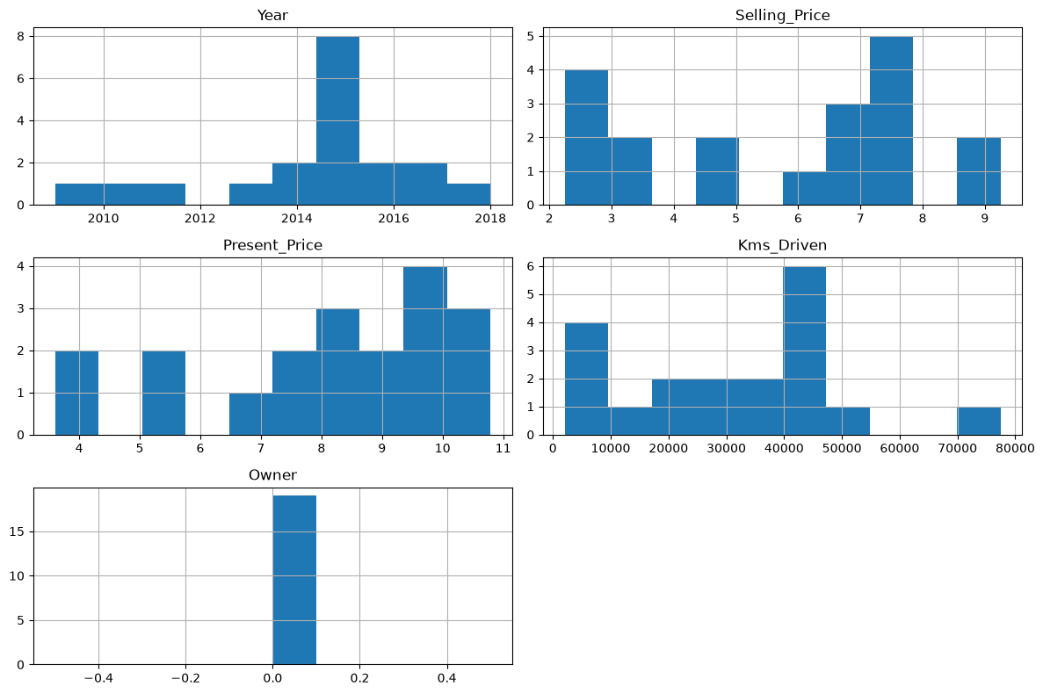
Fig. 1: Exploratory Data Analysis output from the notebook
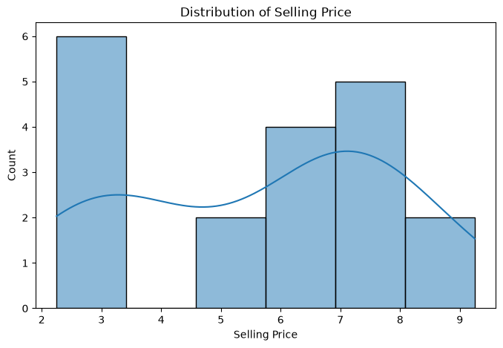
Fig. 2: Exploratory Data Analysis output from the notebook
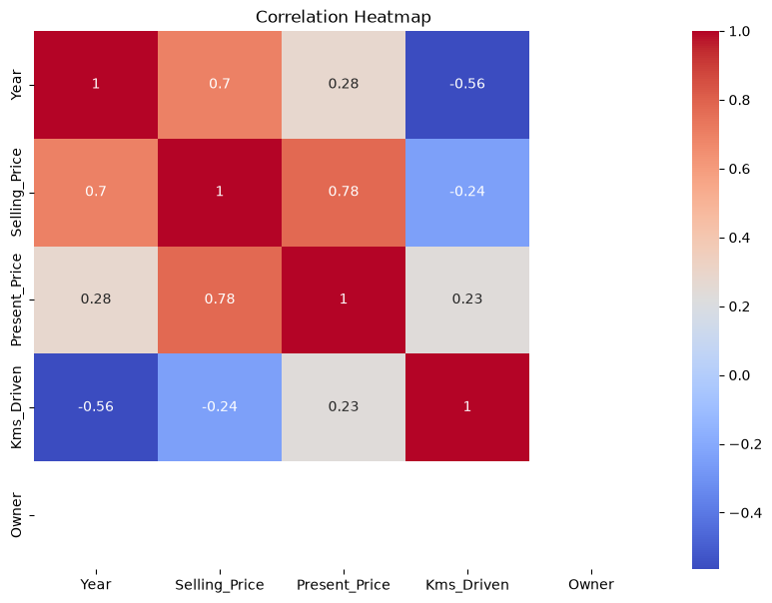
Fig. 3: Exploratory Data Analysis output from the notebook
FEATURE ENGINEERING / FEATURE SELECTION
A new feature named Car_Age is created from Year. The final feature set is Present_Price, Kms_Driven, Fuel_Type, Seller_Type, Transmission, Owner, and Car_Age. The target variable is Selling_Price.
MODEL DEVELOPMENT
Four regression models are trained: Linear Regression, Decision Tree Regressor with max_depth=5, Random Forest Regressor with n_estimators=200, and Gradient Boosting Regressor.
EXPERIMENTAL SETUP
The implementation uses Python, Pandas, NumPy, Matplotlib, Seaborn, and Scikit-learn. After duplicate removal, the data is split into 15 training records and 4 testing records using an 80:20 split with random state 42.
MODEL VALIDATION
Models are trained on the training set and evaluated on the same unseen test split for fair comparison.
HYPERPARAMETER TUNING
Random Forest is tuned using GridSearchCV with 5-fold cross-validation and R² scoring. The search includes n_estimators values 100 and 200, max_depth values None, 5, and 10, and min_samples_split values 2 and 5. The best parameters are max_depth=None, min_samples_split=2, and n_estimators=200.
MODEL EVALUATION
MAE measures average absolute prediction error. RMSE gives greater weight to larger errors. R² Score measures the proportion of variance explained by the model.
MODEL COMPARISON
Model | MAE | RMSE | R² Score
Linear Regression | 0.779860 | 1.012270 | 0.793617
Decision Tree | 1.583333 | 1.857268 | 0.305248
Random Forest | 1.321188 | 1.541516 | 0.521396
Gradient Boosting | 1.301122 | 1.647317 | 0.453444
Tuned Random Forest | 1.321188 | 1.541516 | 0.521396
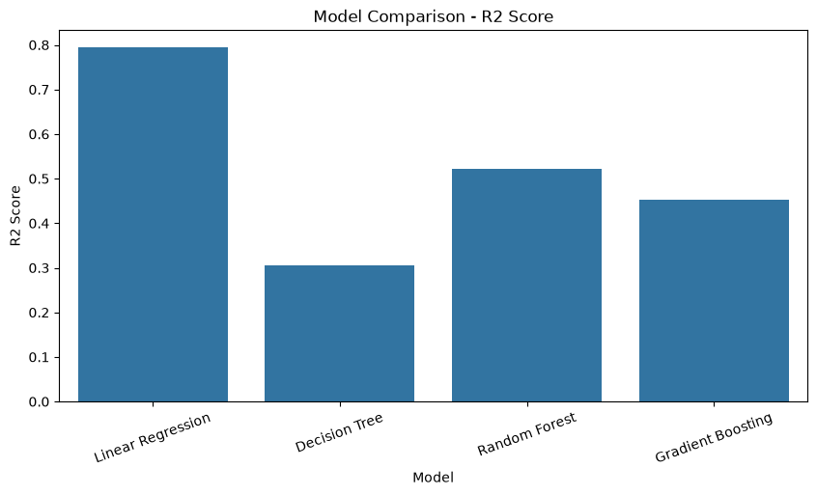
Fig. 4: Model Performance Comparison from the notebook
FINAL MODEL SELECTION
Linear Regression is selected as the final model because it achieved the highest R² Score (0.793617) and the lowest MAE (0.779860) and RMSE (1.012270).
SAMPLE / UNSEEN DATA PREDICTION
The notebook demonstrates prediction on a new unseen car. The GridSearchCV Random Forest prediction is 3.62325 in the dataset price unit, converted in the notebook to an estimated selling price of ₹362,325.
RESULTS
Linear Regression performs best on the available test data. Decision Tree gives the weakest R² Score, while Random Forest and Gradient Boosting provide intermediate results.
DISCUSSION
The experiment demonstrates that a more complex ensemble model does not always outperform a simpler linear model, especially on a very small dataset. The Linear Regression model provides the strongest result in this experiment.
LIMITATIONS
• The cleaned dataset contains only 19 records, limiting generalization.
• The test set contains only 4 records.
• Results may change substantially with a larger dataset.
• The notebook's unseen prediction uses tuned Random Forest although Linear Regression has the best comparison result.
• Some potentially useful vehicle attributes are not included in the final feature set.
CONCLUSION
This project developed an end-to-end machine learning solution for used-car selling price prediction using the assigned dataset and notebook workflow. The dataset was cleaned by removing one duplicate row, Car_Age was engineered, and four regression models were trained and evaluated. Linear Regression achieved the best test performance with MAE 0.779860, RMSE 1.012270, and R² Score 0.793617. Random Forest tuning was performed with GridSearchCV, and an unseen-data prediction was demonstrated.
FUTURE SCOPE
• Use a larger and more diverse car dataset.
• Apply k-fold cross-validation.
• Engineer additional features such as brand and model.
• Test advanced models such as XGBoost or LightGBM.
• Perform broader hyperparameter optimization.
• Deploy the model as a web application.
REFERENCES
• T. Hastie, R. Tibshirani, and J. Friedman, The Elements of Statistical Learning, 2nd ed., Springer, 2009.
• L. Breiman, “Random Forests,” Machine Learning, 2001.
• J. H. Friedman, “Greedy Function Approximation: A Gradient Boosting Machine,” Annals of Statistics, 2001.
• F. Pedregosa et al., “Scikit-learn: Machine Learning in Python,” JMLR, 2011.
APPENDIX
• Appendix A: Data Loading and Inspection Code.
• Appendix B: Missing-Value and Duplicate Checking.
• Appendix C: Exploratory Data Analysis Outputs.
• Appendix D: Car_Age Feature Engineering and Preprocessing.
• Appendix E: Regression Model Development.
• Appendix F: Model Evaluation and Comparison.
• Appendix G: GridSearchCV Hyperparameter Tuning.
• Appendix H: Unseen Data Prediction.

